May 1, 2015
Andrew Wilson, PhD, MStat Anolinx 428 E. Winchester, Suite 202 Salt Lake City, UT 84107 Phone: 888-968-5469 Email: awilson@anolinx.com
ICPSR Re: Restricted Data Access for NCS-R
To whom it may concern,
Our study team is requesting the restricted-use version of the National Comorbidity Survey Replication (NCSR), 2001-2003 for the research purpose of reproducing an analysis of the Moving to Opportunity (MTO) Final Youth Survey published last year in the Journal of the American Medical Association (JAMA). Restricted data are required, as publicly available datasets do not provide the data resolution needed to reproduce previous study (Please see Appendix A).
The researchers involved, however, are not considered “Covered Entities” (as deﬁned by the Privacy Rule in Appendix B), nor are working on behalf of a “Covered Entity”, but are independent researchers supported by an independent research company. Due to this, the researchers involved are not required to have IRB oversight, thus the reason for this letter in lieu of IRB documentation.
Please let me know if you have any questions. I am available to discuss further if needed.
Yours sincerely,
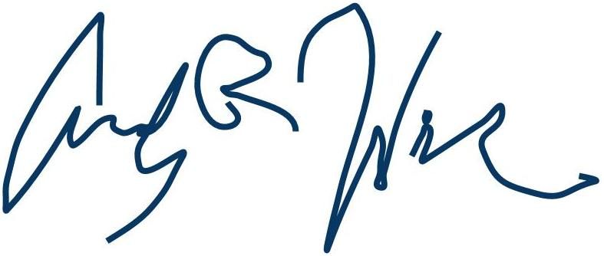
Andrew Wilson, PhD, MStat

Appendix A: Description of Replication Study
In Kessler and colleagues’ recently published analysis of data from the Moving to Opportunity (MTO) Demonstration,3 inferences were made about 1-year prevalence of Posttraumatic Stress Disorder (PTSD) in adolescents, based on the MTO Final Youth Survey. This survey questionnaire, however, incompletely operationalized the DSM-IV PTSD criteria. To overcome this limitation of the MTO data, Kessler et al. singly imputed PTSD outcomes using a logistic regression model estimated against NCSR data, which more completely operationalized these criteria.
This imputation procedure introduced multiple layers of arbitrariness into the conﬁdence intervals reported by Kessler et al. The aim of our reproduction study is to abstract away these layres of arbitrariness to reveal the study estimates in a more appropriate statistical light. One of these layers relates to the selection of the logistic imputation model itself, and in order to address this layer we require access to the NCSR data for reproducing the original model, evaluating its predictive performance, and placing it in the larger context of a variety of alternative models that might reasonably have been considered.

Appendix B -Deﬁnitions
The Privacy Rule
The Privacy Rule, at 45 CFR parts 160 and 164, establishes a category of health information, deﬁned as protected health information (PHI), which a covered entity may only use or disclose to others in certain circumstances and under certain conditions. In general, the Privacy Rule requires an individual to provide signed permission, known as an Authorization under section 164.508 of the Privacy Rule, before a covered entity can use or disclose the individual’s PHI for research purposes. Under certain circumstances, however, the Privacy Rule permits a covered entity to use or disclose PHI for research without an individual’s Authorization. One way a covered entity can use or disclose PHI for research without an Authorization is by obtaining proper documentation of a waiver of the Authorization requirement by an Institutional Review Board (IRB) or a new type of review body, a Privacy Board6.
Covered Entity
Hospitals, academic medical centers, government units, and others engaged in federally conducted or supported health research activities involving human subjects and entities conducting FDA-regulated clinical investigations, among others, have designated IRBs6.
Other covered entities are health plans, health care clearinghouses, and health care providers that transmit health information electronically in connection with certain deﬁned HIPAA transactions, such as claims or eligibility inquiries. Researchers are not themselves covered entities, unless they also provide health care and engage in any of the covered electronic transactions. If, however, researchers are employees or other workforce members of a covered entity (e.g., a hospital or health insurer), they may have to comply with that entity’s new HIPAA privacy policies and procedures. A researcher who is not himself or herself a covered entity or is not a workforce member of a covered entity may be indirectly affected by the Privacy Rule, if a covered entity supplies the research data6.
Research sponsors and researchers who are not covered entities are not required to comply with the Privacy Rule6
References

1. Norris DC. “Housing Mobility and Adolescent Mental Health.” JAMA 312, no. 2 (July 9, 2014): 190-190. doi:10.1001/jama.2014.6468.

2. Cronbach, Lee J., and Paul E. Meehl. “Construct Validity in Psychological Tests.” Psychological Bulletin 52, no. 4 (1955): 281-302. doi:10.1037/h0040957.

3. Kessler RC, Duncan GJ, Gennetian LA, and et al. “Associations of Housing Mobility Interventions for Children in High-Poverty Neighborhoods with Subsequent Mental Disorders during Adolescence.” JAMA 311, no. 9 (March 5, 2014): 937-48. doi:10.1001/jama.2014.607.

4. Kessler RC. Personal communication, Nov 2014.

5. Shadish, Cook & Campbell. Experimental and Quasi-Experimental Designs for Generalized Causal Inference. Boston: Houghton Mifﬂin, 2001.

6. National Institutes of Health. “HIPAA Privacy Rule and Its Impacts on Research.” National Institutes of Health. Last modiﬁed August 2003. http://privacyruleandresearch.nih.gov/irbandprivacyrule.asp.

